**PIEP – InsertionPS**

**User Guide**

## VERSIONING AND CONTROL VALIDATION

VERSIONING HISTORY

|  |  |  |  |
| --- | --- | --- | --- |
| Version | AUTHOR | REVISION | Date |
| 1.0 | RCAS (CGI) | Creation | 06/07/2020 |
| 1.1 | RCAS (CGI) | Prerequisite review | 17/08/2020 |
|  |  |  |  |
|  |  |  |  |
|  |  |  |  |
|  |  |  |  |
|  |  |  |  |

VALIDATION

|  |  |  |
| --- | --- | --- |
| Version | Name | Date |
| 1.0 |  |  |
|  |  |  |

## DOCUMENT CONTENT

1. VERSIONING AND CONTROL VALIDATION 2

2. DOCUMENT CONTENT 3

3. SCRIPT DESCRIPTION 4

3.1 Objective 4

3.2 Prerequisite 4

4. USER GUIDE 5

4.1 Prepare the input file 5

4.2 Configure 01-InsertionPS.bat 5

4.3 Run InsertionPS 6

4.4 Clean the application 6

## SCRIPT DESCRIPTION

### Objective

**The purpose of InsertionPS is to provide in data the tags PI in selected PI Server from csv files**.

The user provide the server name and the files with the data extracted with ExtractionPS.

### Prerequisite

* Microsoft Powershell (1.0 or later).
* Package PI SMT 2018 or later.
* DO NOT run the script on a production environment.

## USER GUIDE

Copy the folder InsertionPS in your local machine/server : **D:\PI\Applications**\.

### 4.1 Prepare the input file

Copy the files from the application InsertionPS to the Input folder.

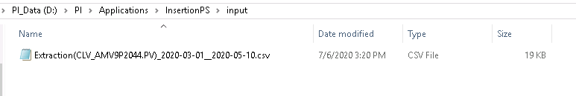

### 4.2 Configure 01-InsertionPS.bat

Edit the file “.\script\01-InsertionPS.bat”.

*cd ..*

*powershell.exe -file .\InsertionPS.ps1 -PIServerHost "SERVER_NAME"*

Modify the following parameters :

* **PIServerHost** : Name of the PI Server to extract tags (exemple : PI-CENTER-HQ)

Then save the modifications and close the file.

### 4.3 Run InsertionPS

**Run the script 01-InsertionPS.bat**.

You should have the following window opened. Let the program provide the data in the tags.

The logs are stored in the “.\logs” directory.

When the line “Press Enter to quit InsertionPS” appear, press Enter to quit.

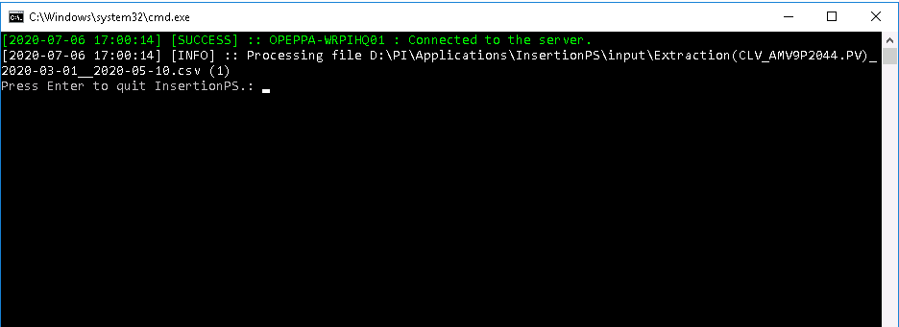

### 4.4 Clean the application

When the insertion is finished, please clean the input directory for the next use.